Supplementary Material

Mammals of the Cerrado domain from Tocantins State, Brazil
Wagner Tadeu Vieira Santiago¹, Carlos Manuel Martins Santos Fonseca¹, Antônio Carlos da Silva Zanzini², Felipe Santana Machado^{23*}, Aloysio Souza de Moura², Marco Aurélio Leite Fontes².
¹ Departamento de Biologia, Universidade de Aveiro, Campus Universitário de Santiago, CEP 3810-193, Aveiro, Portugal.
² Departamento de Ciências Florestais, Universidade Federal de Lavras, CP 3037, Campus Universitário, Lavras, MG, Brasil.
³ Governo do Estado de Minas Gerais, Escola Estadual Profa. Ana Letro Staacks, Av. Sen. Milton Campos, 1 - Quitandinha, Timóteo - MG, 35180-058.
* Autor para correspondência. epilefsama@hotmail.com

Supplementary Material 1. Relation of the study selected areas with their respective physiognomic types of vegetation, according to Ribeiro and Walter (1998). The geographical coordinates are in the "Location" column. The numbers in this Table refer to the same numbers as in Figure 1.
Location | Description
1- 09º48'S 47º 52'W | riparian forest, “Cerradão”, dense Cerrado, typical Cerrado, dirt fields
2- 09º19'S 47º 52'W | riparian forest, “Cerradão”, dense Cerrado, typical Cerrado, dirt fields
3- 8º14'S 47º41'W | riparian forest, “Cerradão”, dense Cerrado, typical Cerrado, dirt fields
4- 07º47'S 47º23'W | riparian forest, “Cerradão”, dense Cerrado, typical Cerrado, dirt fields
5- 09º42'S 48º 21'W | riparian forest, “Cerradão”, dense Cerrado, typical Cerrado
6- 10º20’S 48º46’W | riparian forest, “Cerradão”, dense Cerrado, typical Cerrado, “Vereda”
7- 10°40'S 48°25'W | riparian forest, gallery forests, “Cerradão”, dense Cerrado, typical Cerrado, “Vereda”, dirt fields
8- 12º15’S 48º29’W | riparian forest, gallery forests, “Cerradão”, dense Cerrado, typical Cerrado, “Vereda”
9-12º29’S 48º15’W | riparian forest, gallery forests, “Cerradão”, dense Cerrado, typical Cerrado
10-11º35'S 47º00'W | riparian forest, gallery forests, “Cerradão”, dense Cerrado, typical Cerrado, dirt fields

Supplementary Material 2. Locations and sample effort classification for the medium and large mammal species of the Cerrado domain, Tocantins State, Brazil.
Location | Sample effort (traps-day) | Sample effort – IPM (Km)
1 | 465 | 100.4
2 | 465 | 82.3
3 | 465 | 78.55
4 | 465 | 75.25
5 | 624 | 84
6 | 520 | 90.58
7 | 459* | 90.58
8 | 184* | -
9 | 428* | -
10 | 520 | 321.74
*Non-quantified mileage. The number refers to days of collection.

Supplementary Material 3. Some records and locations (coordinates) for the medium and large mammal species of the Cerrado domain, Tocantins State, Brazil.
Leopardus braccatus - 9°54'43.2"S 48°21'42.6"W | Sapajus libidinosus - 9°48'28.1"S 47°53'09.6"W
 | 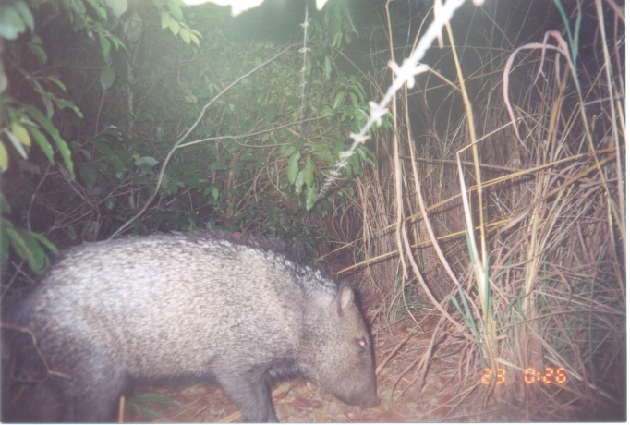
Euphractus sexcinctus - 9°19'54.9"S 47°52'20.6"W | Pecari tajacu - 7°46'26.9"S 47°21'59.5"W
Tamandua tetradactyla - 10°23'03.1"S 48°20'25.3"W | Callithrix penicillata - 10°05'07.3"S 48°22'22.3"W
 | 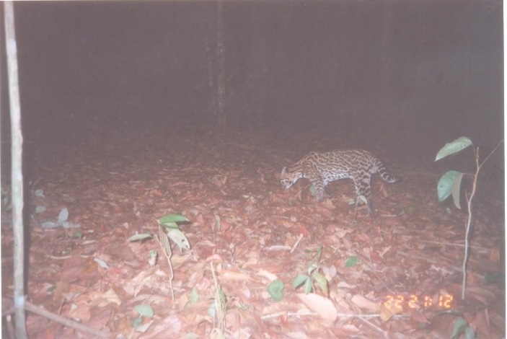
Cerdocyon thous - 9°43'33.7"S 48°21'26.6"W | Leopardus pardalis - 9°48'28.1"S 47°53'09.6"W
Cuniculus paca - 12°20'48.6"S 48°16'07.2"W | Alouatta caraya - 9°53'52.4"S 48°21'25.2"W
Didelphis marsupialis - 9°48'28.1"S 47°53'09.6"W | Mazama gouazoubira - 9°43'32.3"S 48°21'47.8"W
Dasypus novemcinctus - 8°14'21.5"S 47°41'34.7"W | Galictis vitata - 10°15'56.0"S 48°22'48.5"W
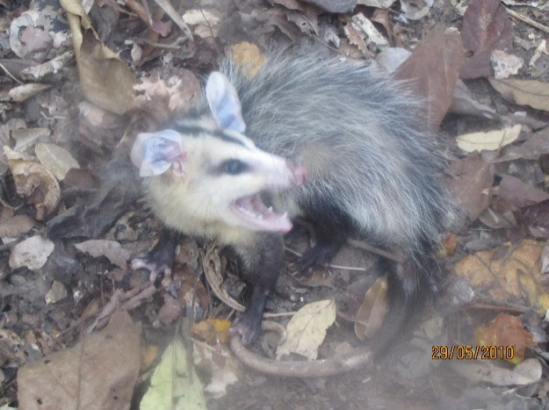 | 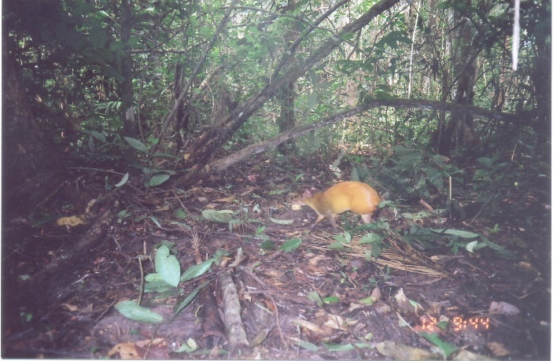
Didelphis albiventris - 12°14'25.0"S 48°21'56.7"W | Dasyprocta leporina - 9°43'20.8"S 48°21'42.6"W
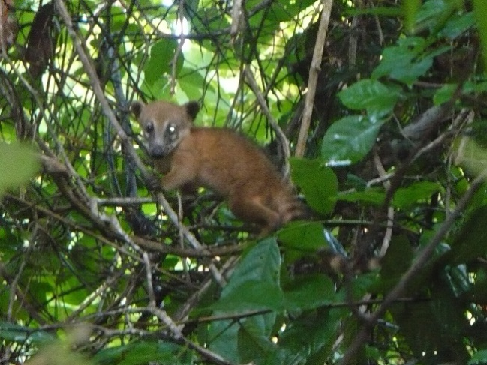
Nasua nasua - 7°46'26.9"S 47°21'59.5"W

